Aerospace Projects

Subject: Aerospace,Physics  Related Subjects: | Grade Level(s):2nd,8th and 9th  Length of Lesson: | Type: Project  Keywords:thrust, drag, lift and gravity

Lesson Overview
Use this section to describe at a high level what the lesson is. Should be no more than 3-4 lines.

Lesson Focus
What is the central question or phenomenon being investigated? What problem are they trying to solve?

Lesson Objective(s) | By the end of this lesson, students will…  - Understand the basic theories and related knowledge of rocket  - Create paper airplanes and other paper stuffs

Lesson Timing

5 minutes | Introduce the Lesson
30 minutes | ...

Materials | Paper Airplanes  - 20 – pieces of paper  - 1 to 2 – rolls of tape  - 20 – paper clips  Cardstock Gliders  - 20 - pieces of cardstock paper  - 1 - roll of tape  - 20 - 60 cm long 1/8” dowels  - 20 - sheets of wax paper (approx. 35 cm long)  - 10 - glue sticks (not glue gun kind)  - 10 – scissors  Loop glider  - 20 - straws  - 20 - 3 x 5 cards  - 1 - roll of tape  - 10 - scissors  Straw Rockets  - 20 - Straws  - 20 - 3 x 5 cards  - 1 to 2 - rolls of tape  - 10 - sheets of paper  - 10 - scissors  Stomp Rockets  - 2 – 1L or 2L bottles  - 20 – sheets of card stock paper  - 1 to 2 – rolls of masking tape  - 10 – scissors  - 12” – flexible pipe insulator (to be cut into two 6” pieces)  - 6’ – PVC pipe (to be cut into four 18” pieces)  Balloon Rocket  - 20 - Balloons  - Thread or dental floss  - 20 - Straws  - 1 to 2 – rolls of tape  Balloon Jet  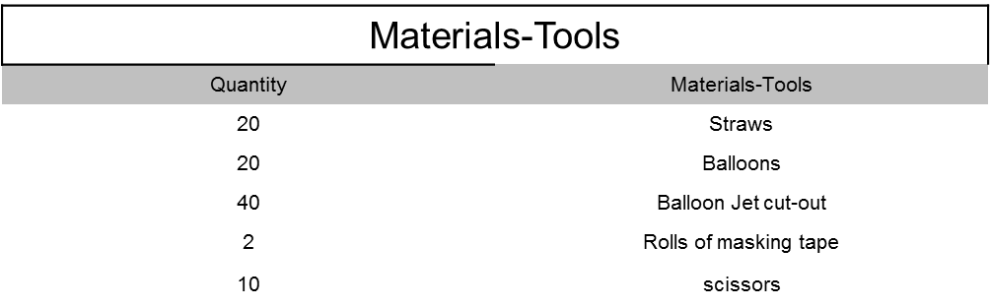  Whirly Birds  - 20 – Craftsticks  - 3 – Hot glue guns  - 9 – Hot glue sticks  - 20 – 1/8" wood dowels  - 5 – Pieces of sand paper  Paper Copter  - 20 – Sheets of paper  - 20 – Paper clips  - 10 – Scissors  Kite  - 20 – 100 cm dowels  - 20 – 90 cm dowels  - 20 – Sheets of wax paper  - 2 – Rolls of tape  - 3 – Hot glue guns  - 9 – Hot glue sticks  - 1 – Roll of String  - 20 – Streamers  - 10 – Scissors
Instructor Prep | - Step 1
Related Resources | - List related lessons/ppts etc available from USC or outside, trusted orgs

Lesson Plan

Introduction
Introduce students to the learning goals and make connections to past and present learning experiences. Stimulate interest and prompt students to identify their own questions about the topic. This can link the lesson to real world examples, introduce associated STEM careers, and assess their prior knowledge on the topic.

- Step 1

Procedure
List the steps of the activity. Remember to focus on leading students to the solution, rather than just telling them what to do. Include pictures of steps if you have them. Be sure to include some steps for discussion and reflection.

Paper Airplanes
- Fold 1 sheet of paper lengthwise in half and crease.

- Unfold sheet, and then fold top ends toward center crease line until a triangle is formed at the top and crease.

- Fold top triangle portion down creasing at the bottom of the triangle (top of paper.

- Fold new top ends (bottom of top triangle portion) toward center until they touch approximately ½ inch from triangle point. Top of paper should be flat (approx. 1 inch).

- Fold pointed end of folded triangle over two touching points.

- Backwards fold (away from you) and crease. The folded pointed end should form a pouch and should be on outside.

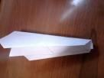
- Fold both angled ends until they align with bottom of glider.

- Extend wings and place tape on wings above pouch.

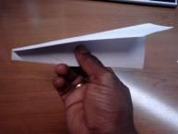
- Students create an airplane of their own design
Cardstock Gliders
- Create the “backbone” of the glider using dowel
- Lay the fuselage on wax paper
- Center and glue the wing, on top of the fuselage, 5cm from the edge
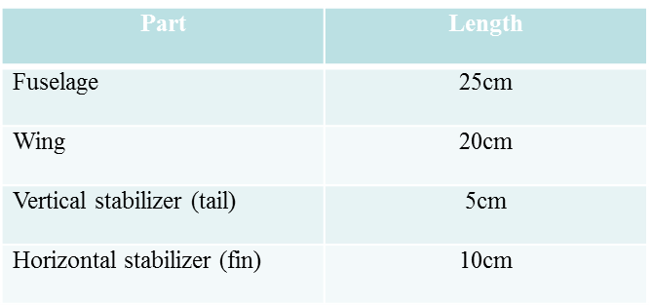
- Center and glue the horizontal stabilizer, on top of the fuselage, 1cm from other edge
- Glue vertical stabilizer perpendicularly on top of the horizontal stabilizer (it should be sticking up
- Glue the glider component sheets to cardstock paper
- Cut out the component parts (trim the fuselage along the dotted lines) from each sheet
- Making sure 1cm of the back end of cardstock fuselage “cut-out” extends beyond the dowel fuselage, glue the cardstock fuselage “cut-out” to one side of the dowel fuselage (using the glue stic and not the glue gun).
- Repeat for the other cardstock fuselage “cut-out”
- Trim the portion of the dowel fuselage that extends beyond the front of the cardstock fusealage “cut-out”
- Lightly tape the two cardstock “cut-outs” together along all common edges of the front, bottom and back.
- Glue the dowel wing to the cardstock “cut-out” wing 3cm from the straight side of the cardstock “cut-out” wing
- Repeat for bottom of wing.
- Lightly tape the two card stock “cut-outs” together along all common edges
- Repeat prior 3 steps for other wings
- Glue the dowel horizontal stabilizer to the cardstock “cut-out” horizontal stabilizer, 1.5cm from the straight side of the cardstock “cut-out” horizontal stabilizer.
- Repeat for bottom of horizontal stabilizer.
- Lightly tape the two cardstock “cut-outs” together along all common edges
- Repeat prior 3 steps for other horizontal stabilizer
- Glue the dowel vertical stabilizer to the cardstock “cut-out” vertical stabilizer, 1.5cm from the straight side of the cardstock “cut-out” vertical stabilizer.
- Repeat for other side of vertical stabilizer.
- Lightly tape the two card stock “cut-outs” together along all common edges
- The glider is now ready to fly
Loop glider
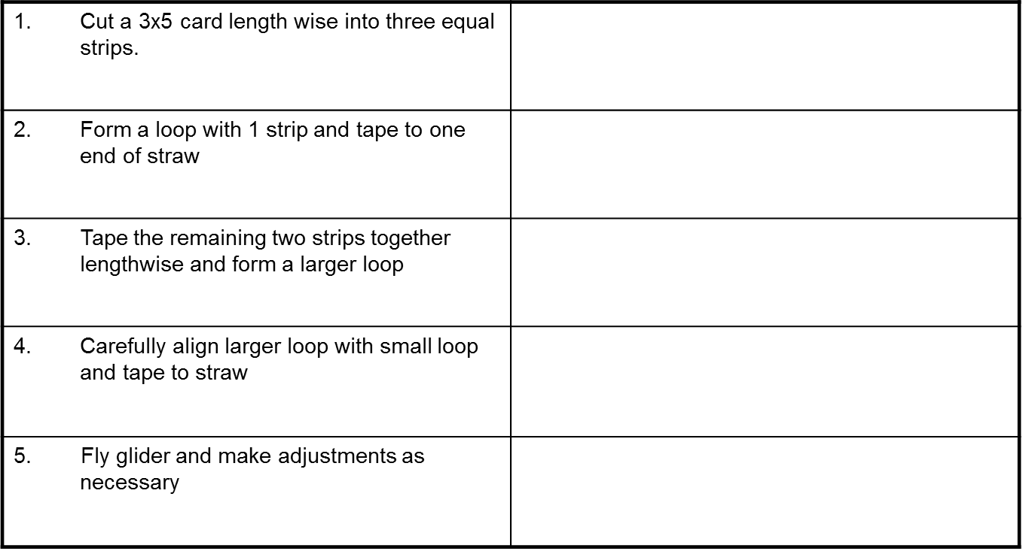

Loop Glider
1. Cut a 3x5 card length wise into three equal strips.

2. Form a loop with 1 strip and tape to one end of straw

3. Tape the remaining two strips together lengthwise and form a larger loop

4. Carefully align larger loop with small loop and tape to straw

Straw Rockets
- Cut sheet of paper in half and trim width of paper 1inch shorter than straw.
- Create paper tube by rolling paper on straw snugly and tape. (It will be lighter and fly better if only half a sheet of paper is rolled around the straw)
- Remove straw
- Cut small circle from remains of sheet and cut small triangle out of the circle.
- Create a cone from circle and tape to top of paper tube.
- Cut 3 (or four) triangles from 3x5 card.
- Tape to the end of paper tube 120 degrees (or 90 degrees) apart. These are the fins of the rocket which add stability and help maintain flight trajectory.
- Place tube on straw and blow for launch.
- Fly rocket and make adjustments as necessary.
Stomp Rockets
- Wrap sheet of card stock paper around PVC pipe, tape and remove from PVC pipe.
- Cut small circle from cardstock paper and cut small triangle out of the circle.
- Create a cone from circle and tape to top of paper tube.
- Cut 3 (or four) equal small triangles and tape to bottom of rockets equally spaced 120° (or 90°).
- Cut 2-18” pieces of PVC.
- Cut 6” of pipe insulator.
- Insert PVC pieces into either end of pipe insulator. This is your launcher. Make two launchers.
- Place rocket on launcher.
- Insert launcher into bottle.
- Aim rocket away from students.
- Have student jump on bottle to launch.
Balloon Rocket
- Attach one end of a 25 – 30 ft string to a fixed object.
- Tape balloon to one end of straw.
- Students will thread other end of string through straw.
- To launch the rocket, blow up balloon through straw and let it go.
- Launch rocket and observe distance traveled.
Balloon Jet
- Cut out wings, vertical and horizontal stabilizers from two cut-outs
- Tape together matching pieces from
  - Left and right wings
  - Left and right horizontal stabilizers
  - Vertical stabilizer
- Tape wings together (slanted edge forward) to straw about 1 ½” from edge of straw
- Tape horizontal stabilizers together(slanted edge forward) about 1” from the other end of straw to their straight edge
- Center on straw and tape vertical stabilizer right above horizontal stabilizer
- Tape balloon to front of jet so that air doesn’t seep out of the sides
- Blow up balloon through straw and release
Whirly Birds
- Cut an 8" dowel
- Sand two sides of the top of the dowel at a 30 degree angle (see figure 1). It shouldn’t be sharpened like a pencil. It should be flat on two sides
- Sand one end of both craft sticks so that one end is more narrow. (see figure 2)
- Glue the end of one craft stick so that it extends one way from the dowel.
- Glue the end of second craft stick so that it extends the other way from the dowel. (see figure 3)
- Hold dowel in between yours hand, slide one hand toward you and the other away and release.
Paper Copter
- Cut sheet of paper in half length-wise.
- Fold & unfold “half sheet” in half width-wise creating a “middle mark”
- Cut along “middle mark” of half sheet mark 1/3 of the way on each side.
- Fold along cuts and paper clip in place (this is the bottom half).
- Cut ¾ way down the middle of top half.
- Fold paper in opposite directions to create to flaps.
- The paper copter is now ready to fly
Kite
- Cut two dowels 100cm and 90cm
- Make a cross with the two dowels, with the shorter stick (90 cm) placed horizontally across the longer stick (100cm). Make sure that both sides of the cross piece is equal in width.
- Tie the two dowels together with the string at right angles to each other and glue them in place.
- Cut notches at both ends of each dowel deep enough for the string to fit in to. Cut a piece of string long enough to stretch all around the kite frame. Make a loop in the top notch and fasten it by wrapping the string around the stick. Stretch the string through the notch on the right cross-piece, and make another loop. Stretch the string through the notch at the bottom and make another loop. Stretch the string through the notch left cross-piece and make another loop. Wrap the string a few times around the top of the stick and cutoff what you don't need. This string frame must be tight, but not bend the sticks.
- Lay the wax paper on the table and place the dowel frame face down on top. Cut around the frame leaving a 3cm for a margin.
- Fold these edges over the string frame and tape down so that the material is tight.
- Cut a piece of string about 125 cm long, and tie the string to the loops at the top and bottom with about 20 cm hanging off of the bottom.
- Tie another small loop in the string just above the intersection of the two cross pieces.
- Cut a piece of string about 100 cm long, and tie the string to the loops on the left and the right through the small loop in the string just above the intersection of the two cross pieces. This will be the kite's bridle, the string to which the flying line is attached.
- Tie small a small ribbon to the tail piece hanging from the bottom
- Hold the string by the small loop in the center. The kite should be balanced from left to right. You may need to add tape to counterbalance the weight
- Attach flying line.

Wrap-up
End the lesson with some final discussions about what students designed/discovered. Connect their activity back to the focus question/problem, real world examples, and STEM careers.

Also include notes about any special cleanup considerations

Lesson Background for Teachers

Suggested Real-World STEM Connections
- List possible related Role Models in STEM (with details and links to more reading). Give suggestions for examples of scientists/engineers who are from underrepresented groups in STEM in related careers.
- List related real-world engineering problems and examples

Lesson Variations and Options
Include descriptions of alternative methods or ways to present things.

Explanation
Describe the background concepts and explanations behind the lesson. This can be more in depth than a teacher/instructor would actually share with students.

Key Concepts and Vocabulary
- Word 1: Grade Appropriate Definition
- Word 2: Grade Appropriate Definition

Safety Notes
- Safety instruction

